**Ivanov, Georgy Vladimirovich Ivanov (Иванов, Георгий Владимирович, 1894–1958)**

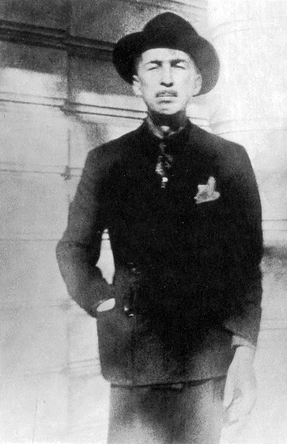Along with Khodasevich and Tsvetaeva, Georgy Ivanov was one of the three great Russian poets of émigré Paris – and the most important representative of the so-called “Parisian Note”.

As a young man in Petersburg, he had been close to the Acmeists. For several years after settling in Paris with his wife, the poet and memoirist Irina Odoevtseva, he wrote little, but in the early 1930s he began writing the poems by which he is remembered – poems of brilliant despair that both anticipate Existentialism and look back to the French Symbolists, and to their Russian translator, Innokenty Annensky. He went on writing better and better, his formal grace coexisting with an ever more startling emotional directness. He composed much of his finest work during his last few months, when he knew he was dying.

Ivanov was a controversial figure. Several memoirs portray him as a monster of egotism, nihilism and worse. He incurred the fury of Anna Akhmatova, Nadezhda Mandelstam and others by publishing a memoir, *Petersburg Winters*, that mixes fact, rumour and fantasy. He was accused of Nazi sympathies and even of complicity in a murder in Petersburg. It is now clear that these rumours were unfounded.

Until 1943 the Ivanovs were wealthy; Odoevtseva’s father was a rich lawyer in Latvia and he supported them financially. Much of the hostility directed at them was probably inspired by envy. But by the end of the War the Ivanovs were penniless; Latvia was a part of the Soviet Union and their villa in Biarritz had been destroyed during an Allied bombing raid. From 1955 until Ivanov’s death they lived not far from Nice – in a home for old people with no citizenship.

**References and Further Reading:**

Andrei Ariev, *Zhizn’ Georgiya Ivanov* (Zvezda, 2009)

V.P. Kreid, *Georgii Ivanov* (Molodaya Gvardiya, 2007)

Both the above are detailed and carefully researched.

**Poetry**

Otplytie na ostrov Tsiteru (*Embarkation for the Island of Cythera*) [Petersburg, 1912]

Gornitsa (*The Chamber*) [Petersburg, 1914]

Pamyatnik Slavy (*Memorial of Fame*) [Petersburg, 1915]

Veresk (*Heather*) [Petersburg, 1916]

Sady (*Gardens*) [Petrograd, 1921 and Berlin, 1922]

Lampada (*Icon Lamp*) [Petrograd, 1922)

Rozy (*Roses*) [Paris, 1931]

Otplytie na ostrov Tsiteru (*Embarkation for the Island of Cythera*) [Paris, 1937] A selection of new poems is followed by selections first from *Roses,* then from *Gardens* and lastly from *Heather*.

Portret bez skhodstva (*Portrait without Likeness*) [Paris, 1950]

Stikhi 1943—1958 (*Poems 1943-58*) [New York, 1958] Published a few months after Ivanov’s death.

**Prose**

Peterburgskie zimy — (*Petersburg Winters*) [Paris, 1928]

Tretii Rim (*The Third Rome*) [part 1 in Sovremennye zapiski, № 39-40, 1929; fragments from part 2 in Chisla, № 2-3, 1930] An amibitious, but never completed novel.

Raspad atoma (*Disintegration of the Atom*) [Paris, 1938] An example of Ivanov’s prose at its most modernist.

Peterburgskie zimy, (*Petersburg Winters*) [New York, 1952]. Expanded edition with added material about Blok, Esenin and Gumilev.

**Main posthumous publications**

Sobranie stikhotvorenii (*Collected Poems*) (Wurzburg, 1975). Includes the first complete publication of the cycle his widow titled “Posthumous Diary”.

Sobranie sochinenii (*Collected Works in three volumes*) [Moscow: Soglasie, 1993-1994]

Stikhotvoreniya (*Poems*) [Petersburg: Novaia biblioteka poeta, 2010]

Georgy Ivanov, On the Border of Snow and Melt: Selected Poems, tr. Jerome Katsell and Stanislav Shvabrin, (Perceval Press, 2011 – bilingual Russian-English edition)

**Robert Chandler, Queen Mary, University of London**

Source url for image: <http://www.peremeny.ru/column/view/1078/>